**PALMORA VISUAL ANALYSIS**

**Analysis & Dashboard Report**

**Dataset Summary:** Product listings with fields such as Name, Gender, Department, location, Bonus rules, Bonus, salary, New Salary, Rating, Salary Band and minimum Salary.

**Analysis Task**

**Key Tasks and Insights**

1. What is the gender distribution in the organization? Distil to regions and departments

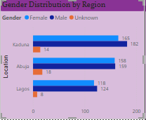

2. Show insights on ratings based on gender

3. Analyse the company’s salary structure. Identify if there is a gender pay gap. If there is, identify the department and regions that should be the focus of management

Company Salary Structure & Gender Pay Gap Analysis

Salary Structure Overview

* The company’s salary structure is organized by department and gender, with totals provided for current and new salaries.
* Salary increases are implemented across all departments, with an overall salary increase of approximately 2.6%.

Gender Pay Gap Analysis

1. Overall Gender Pay Gap

* **Current Salaries:** The ratio of total female to male salaries is approximately **1.05**, indicating that, on average, female employees collectively earn slightly more than male employees.
* **New Salaries:** The ratio drops to **0.32**, suggesting a significant shift where male salaries now far exceed female salaries in aggregate. This indicates the emergence of a substantial gender pay gap in the new salary structure.

2. Departmental Gender Pay Gap

The following table summarizes the gender pay gap by department, calculated as the ratio of female to male salaries (values below 1 indicate females earn less than males):

| **Department** | **Female/Male Current** | **Female/Male New** |
| --- | --- | --- |
| Accounting | 0.83 | 0.99 |
| Business Development | 1.61 | 1.01 |
| Engineering | 1.17 | 0.12 |
| Human Resources | 2.78 | 0.28 |
| Legal | 0.65 | 0.08 |
| Marketing | 1.01 | 0.21 |
| Product Management | 0.81 | 0.08 |
| Research & Development | 1.08 | 0.11 |
| Sales | 0.88 | 0.09 |

3. Key Findings

* **Significant Gender Pay Gaps in New Salaries:**
  + *Engineering, Legal, Product Management, Research & Development, Sales, and Marketing* show a sharp drop in the female/male salary ratio for new salaries, with values well below 1 (often below 0.2).
  + This indicates that after the new salary adjustments, male employees in these departments are paid substantially more than their female counterparts.
* **Departments with Less Gap or Favoring Females:**
  + *Business Development* and *Accounting* have ratios close to 1 for new salaries, suggesting near parity.
  + *Human Resources* shows a drop but still has a higher ratio than most other departments.

Recommendations for Management Focus

* **Departments Requiring Immediate Attention:**
  + **Engineering**
  + **Legal**
  + **Product Management**
  + **Research & Development**
  + **Sales**
  + **Marketing**
* These departments exhibit the largest gender pay gaps in the new salary structure and should be prioritized for pay equity reviews and corrective action.
* **Data Quality Note:**
  + No regional data is available in the provided dataset. Focus should remain on departmental disparities unless further regional breakdown is supplied.

Actionable Steps

* **Conduct detailed pay equity audits** in the highlighted departments.
* **Review and adjust salary policies** to ensure fair and equitable pay for all genders.
* **Improve data collection** on gender and other diversity metrics to enable more granular analysis in the future.

**Summary:**  
The new salary structure introduces a pronounced gender pay gap in several key departments, with male employees receiving disproportionately higher salaries than female employees. Management should focus on the departments listed above to address these disparities and ensure equitable compensation practices.

4. A recent regulation was adopted which requires manufacturing companies to pay employees a minimum of $90,000 ● Does Palmoria meet this requirement? ● Show the pay distribution of employees grouped by a band of $10,000. For example: ● How many employees fall into a band of $10,000 – $20,000, $20,000 – $30,000, etc.? ● Also visualize this by regions Case Questions

Analysis: Palmoria's Compliance with Minimum Salary Regulation

Regulation Requirement

* **Minimum salary required:** $90,000 (as per new regulation for manufacturing companies)

Palmoria's Salary Compliance (Based on the Chart)

* **Compliant Employees:** 654 (69.13%)
* **Non-Compliant Employees:** 292 (30.87%)

Conclusion

**Palmoria does NOT fully meet the minimum salary requirement.**

* Nearly one-third (30.87%) of employees are currently earning below the mandated $90,000 minimum salary.
* Only 69.13% of employees comply with the new regulation.

Recommendations for Management

1. **Immediate Salary Review:**
   * Identify all employees earning below $90,000.
   * Develop a plan to adjust their salaries to at least the minimum required.
2. **Compliance Monitoring:**
   * Establish regular audits to ensure ongoing compliance with salary regulations.
3. **Risk Management:**
   * Address non-compliance promptly to avoid legal penalties, reputational damage, and potential employee dissatisfaction.

**Summary:**  
Palmoria must take swift action to bring the 292 non-compliant employees up to the $90,000 minimum salary to fully comply with the new regulation.

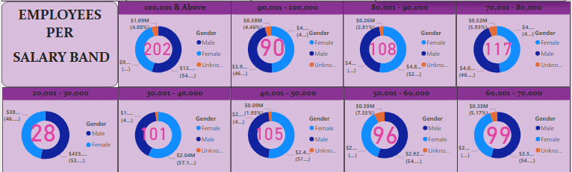

5. Mr Gamma thought to himself that since you were already working on the employee data, you could help out with allocating the annual bonus pay to employees based on the performance rating. He handed you another data set that contains rules for making bonus payments and asked you to:

● Calculate the amount to be paid as a bonus to individual employees

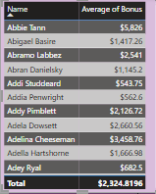

● Calculate the total amount to be paid to individual employees (salary inclusive of bonus)

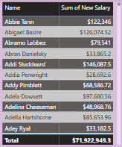

● Total amount to be paid out per region and company-wide

